Department of Computer Science

EE353: Computer Networks
Name: M. Hasnain Naeem
Reg #: 212728
Class: BSCS7AB

Lab 8: Introduction to the Network Layer

Date: 11 NOV 2019
Lab Engineer: Kaleem Ullah

Instructor: Dr. Muhammad Zeeshan

Name:
Regn No:
Current IP address:

Lab Title: Introduction to the Network Layer

1.0 Objective of this lab:

In this lab, we’ll investigate the IP protocol, focusing on the IP datagram. We’ll do so by analyzing a trace of IP datagrams sent and received by the execution of the traceroute program. We’ll investigate the various fields in the IP datagram, and study IP fragmentation in detail.

2.0 Instructions:

- Read carefully before starting the lab.
- These exercises are to be done individually.
- You are supposed to provide the answers to the questions listed in this document (attach screen shots) and upload the completed report to your course’s LMS site.
- Avoid plagiarism by copying from the Internet or from your peers. You may refer to source/ text but you must paraphrase the original work. Your submitted work should be written by yourself.

4. IP fragmentation

4.1 Background:

In this part of the lab, we will try to find out what happens when IP fragments a datagram by increasing the size of a datagram until fragmentation occurs. We will ping with options (use the –s option on MacOS, -l on windows) to set the size of data to be carried in the ICMP echo request message. Note that the default packet size is 64 bytes in MacOS and 32 Bytes in Windows. Once you have send a series of packets with the increasing data sizes, IP will start fragmenting packets that it cannot handle.
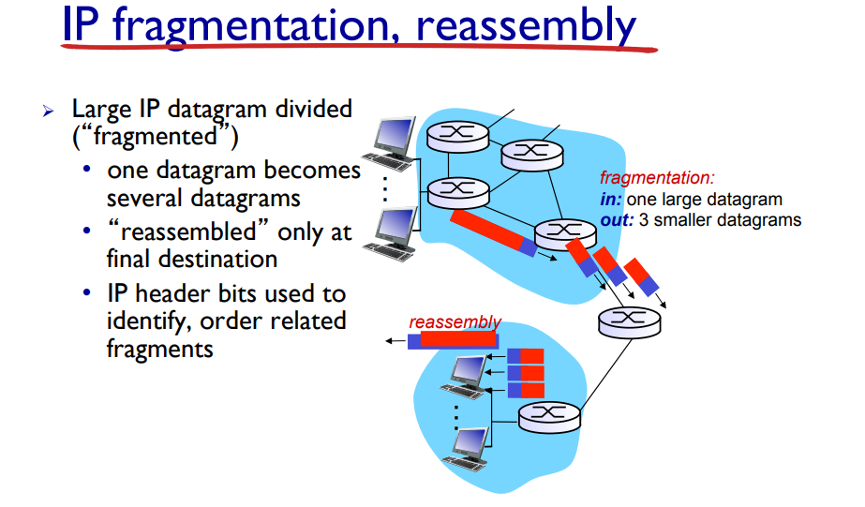
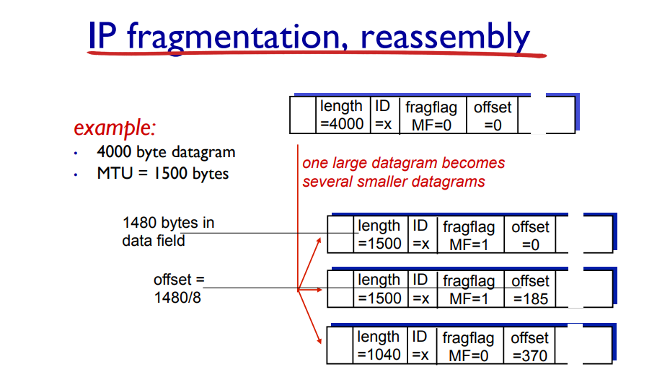
4.2 Steps for performing this part of the lab:

- Startup Wireshark and begin packet capture (Capture->Start) and then press OK on the Wireshark Packet Capture Options screen (we’ll not need to select any options here).
- Startup ping with default values to the target destination as 8.8.8.8
- Stop the wireshark capture when you receive at least 6 replies from target destination.
- Next, repeat the above steps by sending a set of ICMP requests with a length of 2000.
- Finally, repeat again with length value set as 3500

Now answer the following questions.

- Which datagram size has caused fragmentation and why? Which host/router has fragmented the original datagram? How many fragments have been created in this case?
Any size greater than 1472 bytes is causing fragmentation. Because, MTU = 1500 bytes. TCP uses 20 bytes as header size and ICMP uses 8 bytes for header. So, 1500 – 20 – 8 = 1472.

Only 1 fragment was created when length = 1472.
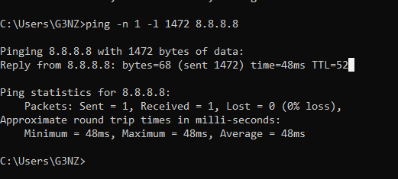
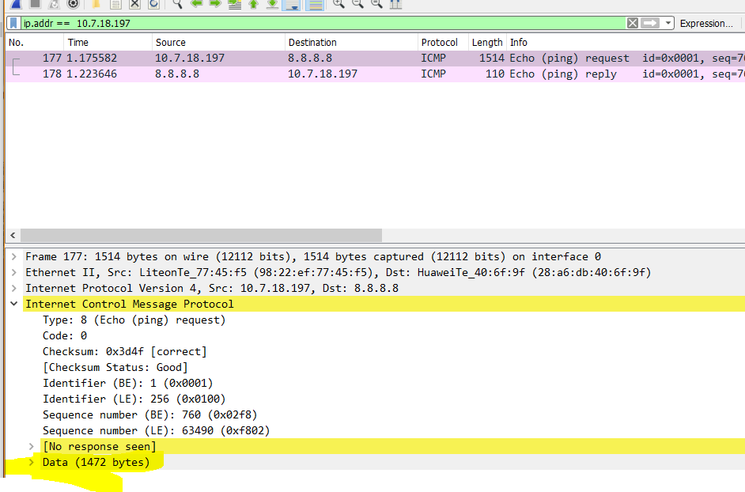

- Did the reply from the destination 8.8.8.8. for 3500 byte datagram also get fragmented? Why and why not?
Yes.
Because MTU = 1500. So, 3500 byte data must be transferred in 3 chunks of size: 1472, 1480, 548. First fragment uses 8 byte ICMP header and 20 byte TCP header. So, total size of 1ST fragment = 1500.
Second fragment uses 20 byte TCP header. So, total size of 2nd fragment = 1500.
Third fragment uses 20 byte TCP header. So, total size of 3rd fragment = 568.
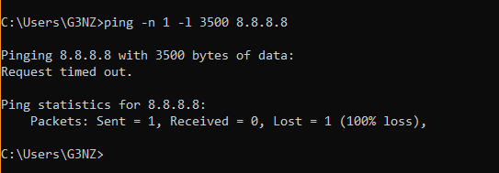

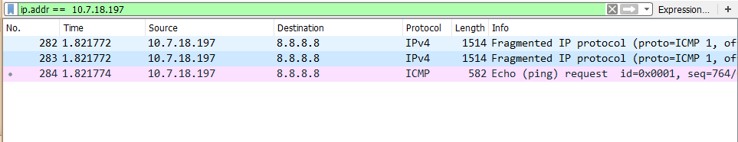
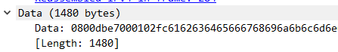
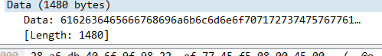
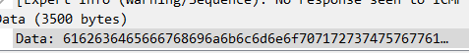
- Give the ID, length, MF and offset values for all the fragments of any single datagram with size 3500 bytes?
For 1st fragment:
ID: 0xd260
Length = 1500
MF: 1
Fragment offset: 0
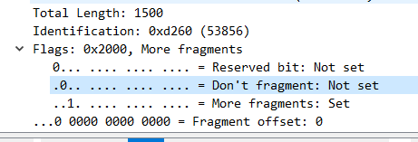
For 2nd fragment:
ID: 0xd260
Length = 1500
MF: 1
Fragment offset: 1480
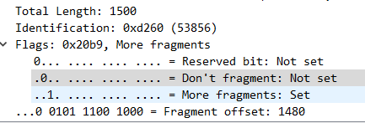

For 3rd fragment:
ID: 0xd260
Length = 568
MF: 1
Fragment offset: 2960

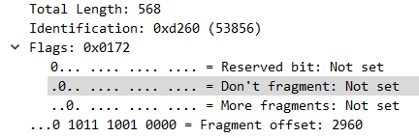

- Has fragmentation of fragments occurred when datagram of size 3500 has been used? Why and why not?
It may occur. If the MTU for each router/host is different, then it will occur.
It is possible that fragment traversing through the network may have the size less than MTU of next router. So, that fragment will be fragmented.

- What is the least MTU value along the complete path to destination? Which is the bottleneck link?
Continuing with assumption, due to timeout issue in the lab, that least MTU will be the IPv4 allowed least.
576 bytes is the minimum supported value in IP infrastructure. So, the bottleneck will be 576 bytes, which can occur anywhere in the network.

Conclusion:
IP datagrams can be analyzed over Wireshark. Analysis conclude that IP datagrams can be fragmented depending on the specifications of a router or host. We can analyze the MTU values in a network by checking the sizes of fragments (and how those fragments are fragmented).

